**Second Year Computing**

**Web Development and Practical Databases**

**CSS Exercises**

**Lab Sheet 2**

**Exercise 1**

Experiment with the CSS box model and the absolute positioning property to produce a webpage that looks similar to the following.

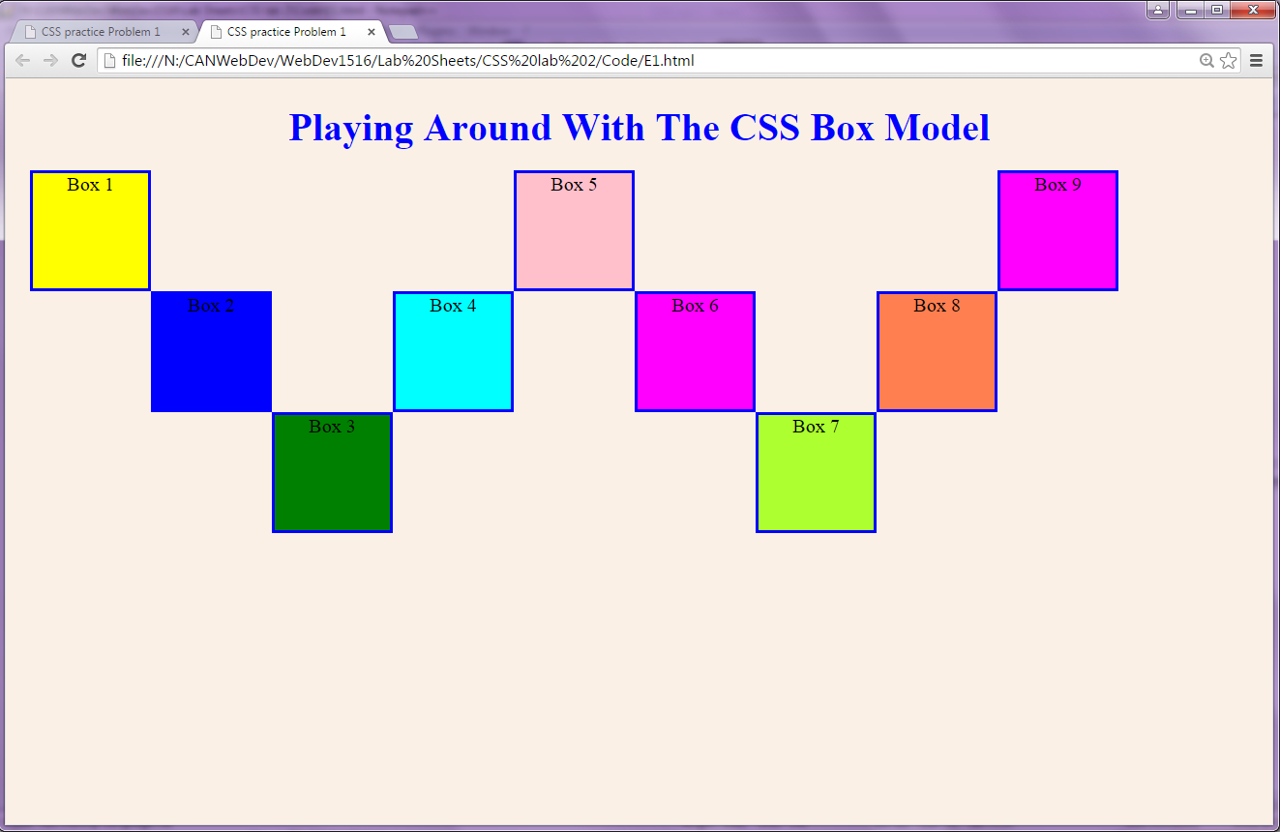

All of these boxes were rendered using absolute positioning, none were rendered in normal flow. Experiment with a mixture of absolute positioning and normal flow and see what happens to the rendering.

In this problem all the boxes are 100 x 100 pixels in size.

Look at the following for a good tutorial on the box model:

[https://www.khanacademy.org/computing/computer-programming/html-css/css-layout-properties/p/css-box-model#](https://www.khanacademy.org/computing/computer-programming/html-css/css-layout-properties/p/css-box-model)

Make sure to use your earphones!!

*Save your exercise files on M/WebDev/CSS Exercises/lab 2/ E1.html, and E1.css*

**Exercise 2**

Create a photo frame on a web page with a number of photos of family and friends. Place each photo in a frame and make up a ‘creative’ collage of the photos.

Use margins, padding etc and position the photos using the position property

The following is just an example of a simple frame!

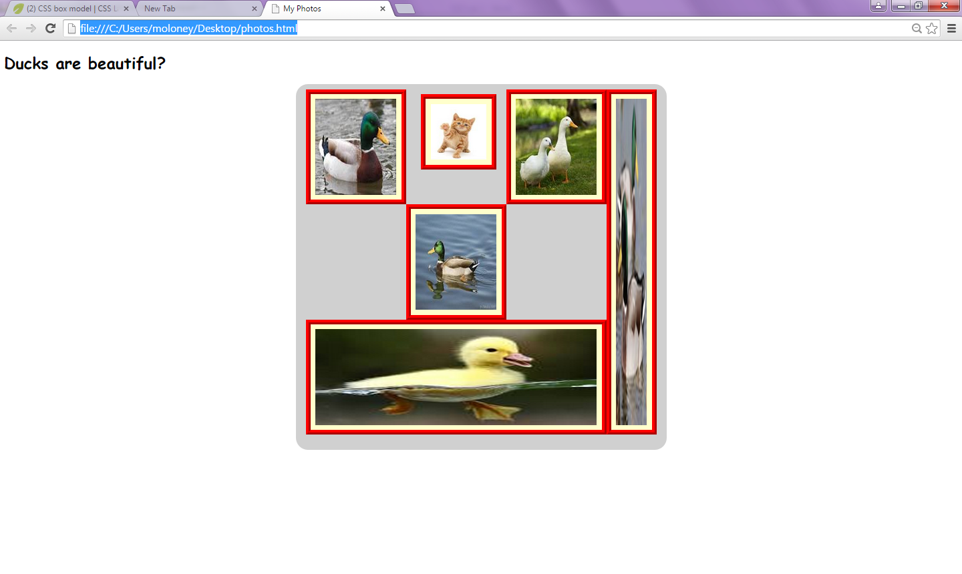

*Save your exercise files on M/WebDev/CSS Exercises/lab 2/ E2.html, and E2.css*

**Exercise 3**

Use the CSS position property to create a webpage that looks like the one below.

Have a look at

<https://www.khanacademy.org/computing/computer-programming/html-css/css-layout-properties/p/css-position> for a good tutorial on positioning

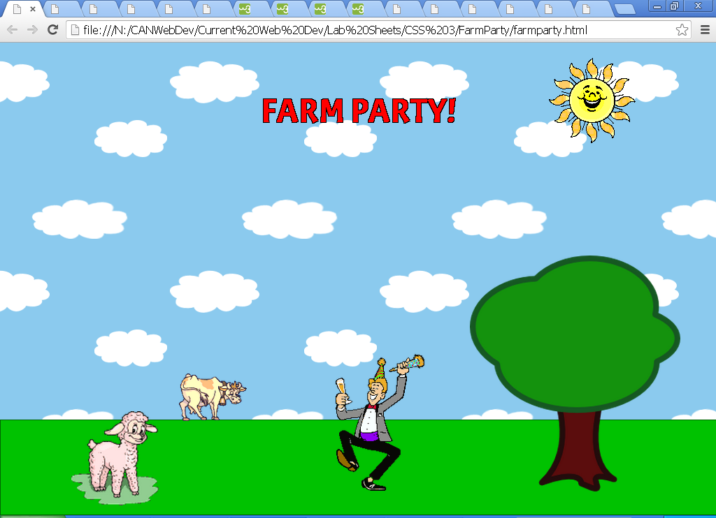

Here are recommended steps for making this happen:

* Create a blank web page with just html, head, body, and a style tag.
* Change the background of the page to be a sky blue and have a background image of clouds.
* Create a div for the grass - position it at the bottom and give it an appropriate height.
* Create a div for the "Farm Party!" banner - position it near the top center area, and style the text so that it's red. For a bonus, use a fun custom font (like from Google Web Fonts) and give it the appearance of a black stroke.
* For each of the images shown, search for an appropriate image on Google Image search - it doesn't have to be exactly the same. Try searches like "sheep animated gif" and if you need to, restrict the results to just "clip art". When you find the image, create a img for it on the page.
* Position each of the img elements appropriately. The sheep should be around the bottom left, the cow should be on the horizon, the man should be dancing in the middle, the tree should be on the front right, and the sun should be around the upper right.
* As a bonus, position a picture of your face on top of the man, and watch yourself have a farm party!

*Save your exercise files on M/WebDev/CSS Exercises/lab 2/ E3.html, and E3.css (if you use it!)*

**Exercise 4**

Display on a web page the royal flush in order, one overlapping the previous one.

The image files for the cards in a royal flush – 10,Jack, Queen, King and Ace of Diamonds are on your common account - Common\WebDev\Images for CSS lab Sheet

Note: In order to use the z-index, you must use relative or absolute positioning. The slide show – CSS Box Model include details on the z-index for layering.

The result should look like this:

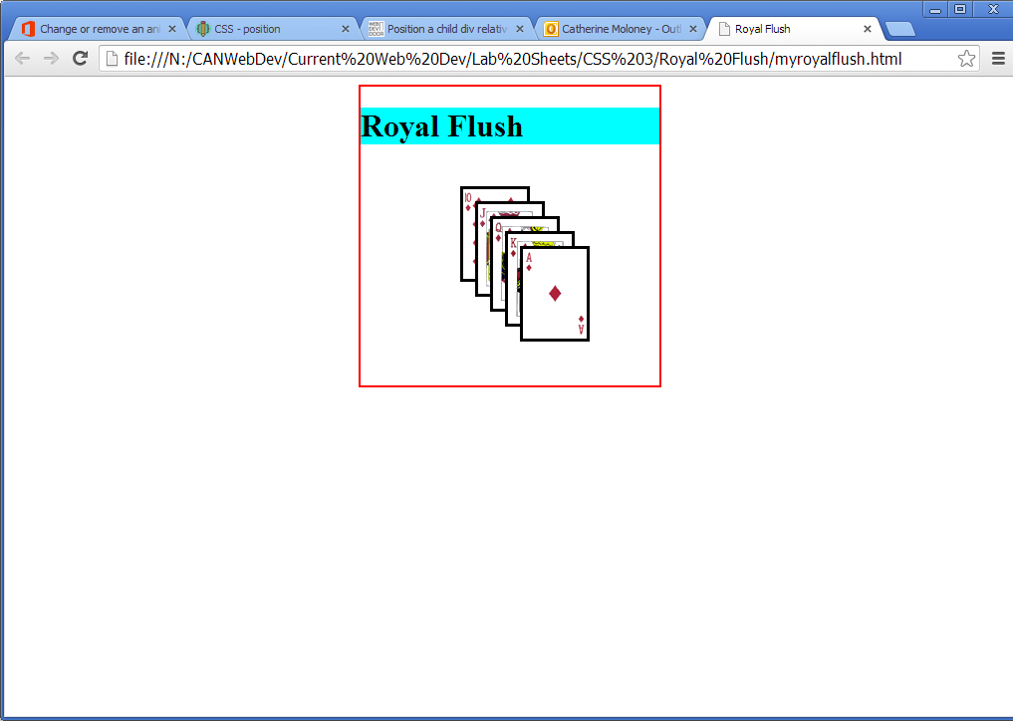

*Save your exercise files on M/WebDev/CSS Exercises/lab 2/ E4.html, and E4.css*